**Dataset**

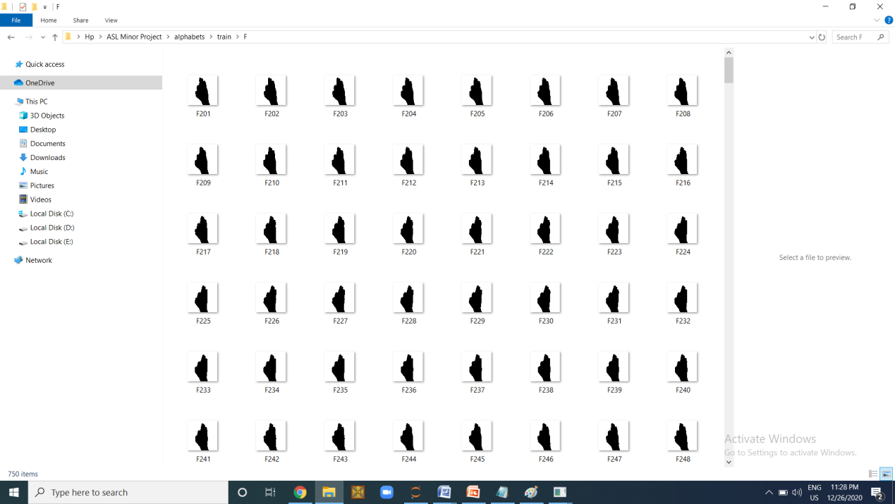

**Prediction**

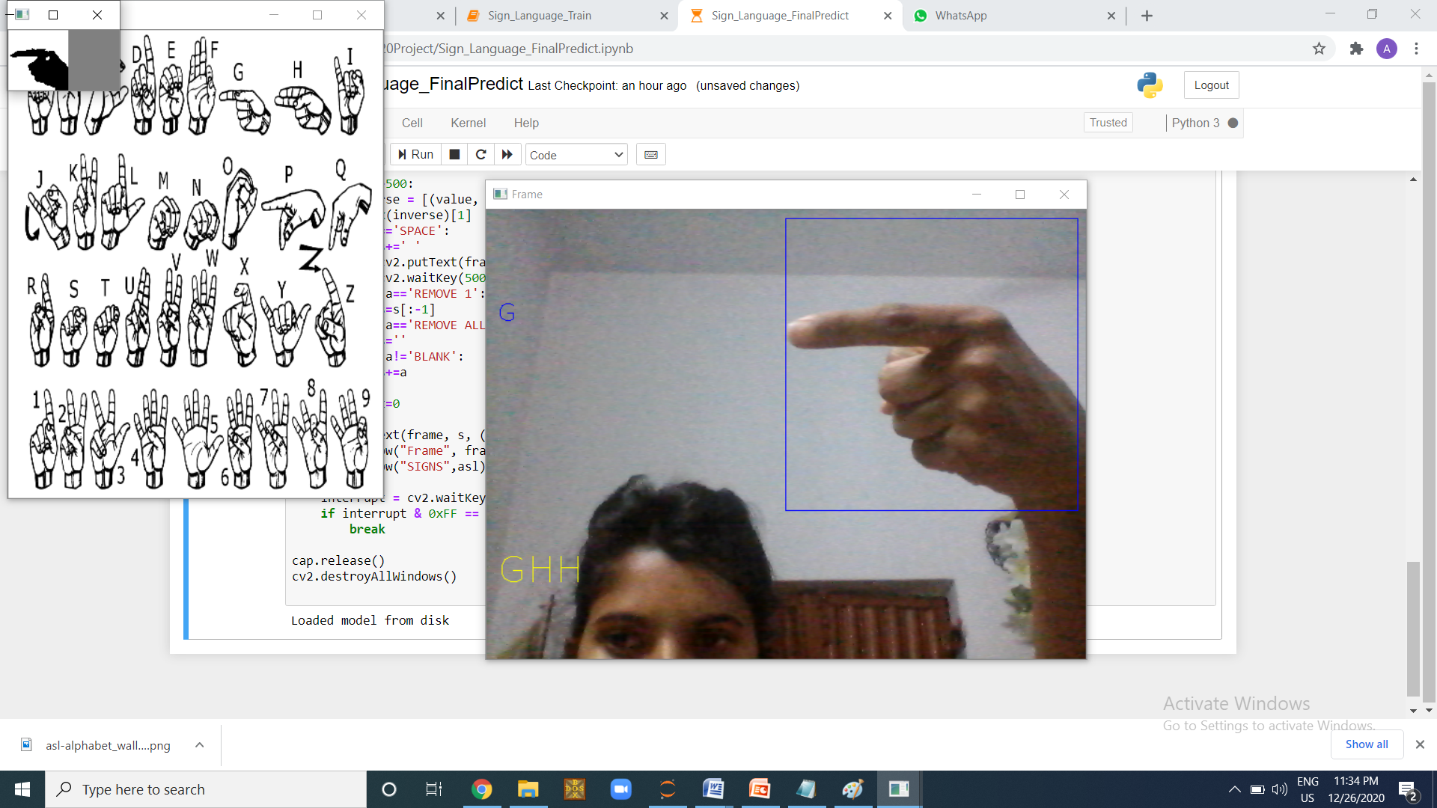

**Training Epoch**

Epoch 1/25

22500/22500 [==============================] - 895s 40ms/step - loss: 0.0646 - acc: 0.9824 - val_loss: 0.7378 - val_acc: 0.9207

Epoch 2/25

22500/22500 [==============================] - 865s 38ms/step - loss: 0.0077 - acc: 0.9981 - val_loss: 0.6174 - val_acc: 0.9411

Epoch 3/25

22500/22500 [==============================] - 826s 37ms/step - loss: 0.0067 - acc: 0.9985 - val_loss: 0.7771 - val_acc: 0.9401

Epoch 4/25

22500/22500 [==============================] - 889s 40ms/step - loss: 0.0049 - acc: 0.9990 - val_loss: 1.0078 - val_acc: 0.9256

Epoch 5/25

22500/22500 [==============================] - 938s 42ms/step - loss: 0.0050 - acc: 0.9992 -

Epoch 21/25

22500/22500 [==============================] - 818s 36ms/step - loss: 0.0159 - acc: 0.9989 - val_loss: 1.0940 - val_acc: 0.9293

Epoch 22/25

22500/22500 [==============================] - 835s 37ms/step - loss: 0.0152 - acc: 0.9989 - val_loss: 0.8378 - val_acc: 0.9464

Epoch 23/25

22500/22500 [==============================] - 826s 37ms/step - loss: 0.0139 - acc: 0.9990 - val_loss: 0.9330 - val_acc: 0.9413

Epoch 24/25

22500/22500 [==============================] - 817s 36ms/step - loss: 0.0149 - acc: 0.9990 - val_loss: 0.8196 - val_acc: 0.9475

Epoch 25/25

22500/22500 [==============================] - 857s 38ms/step - loss: 0.0106 - acc: 0.9992 - val_loss: 1.0233 - val_acc: 0.9348

**Senetence Formation**

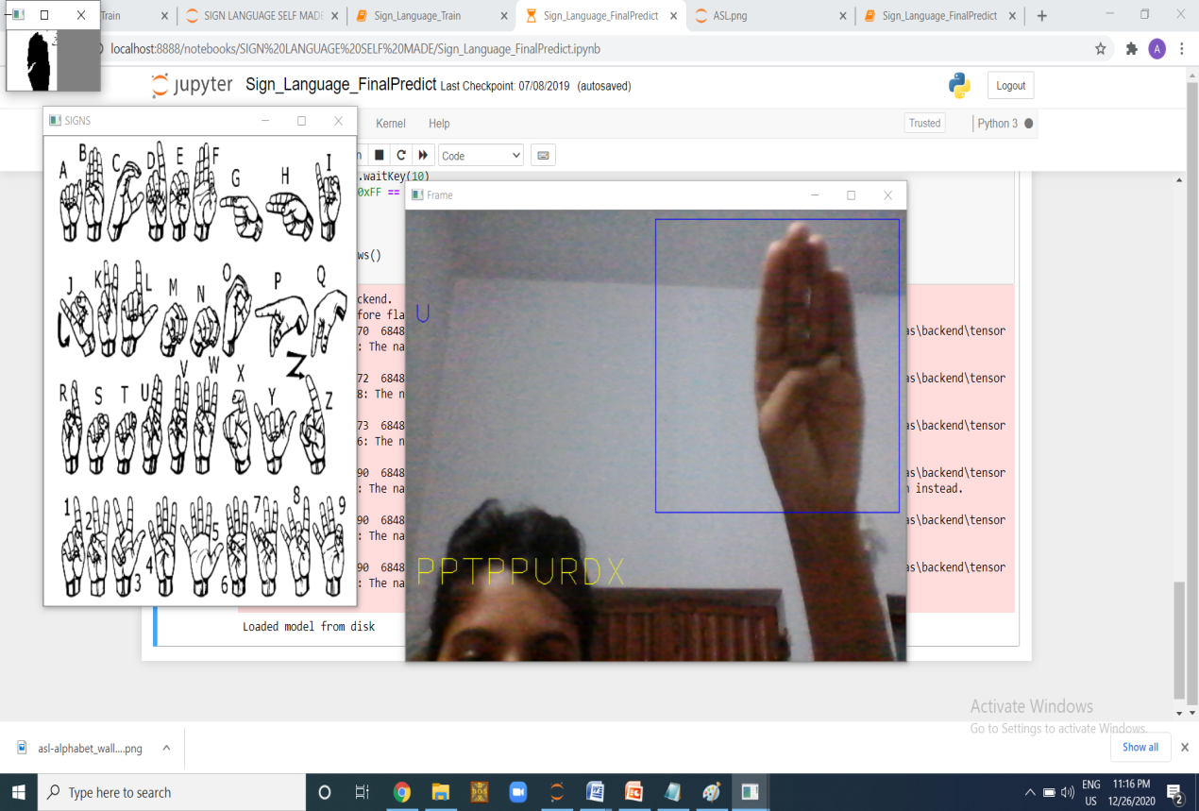

**Blank**

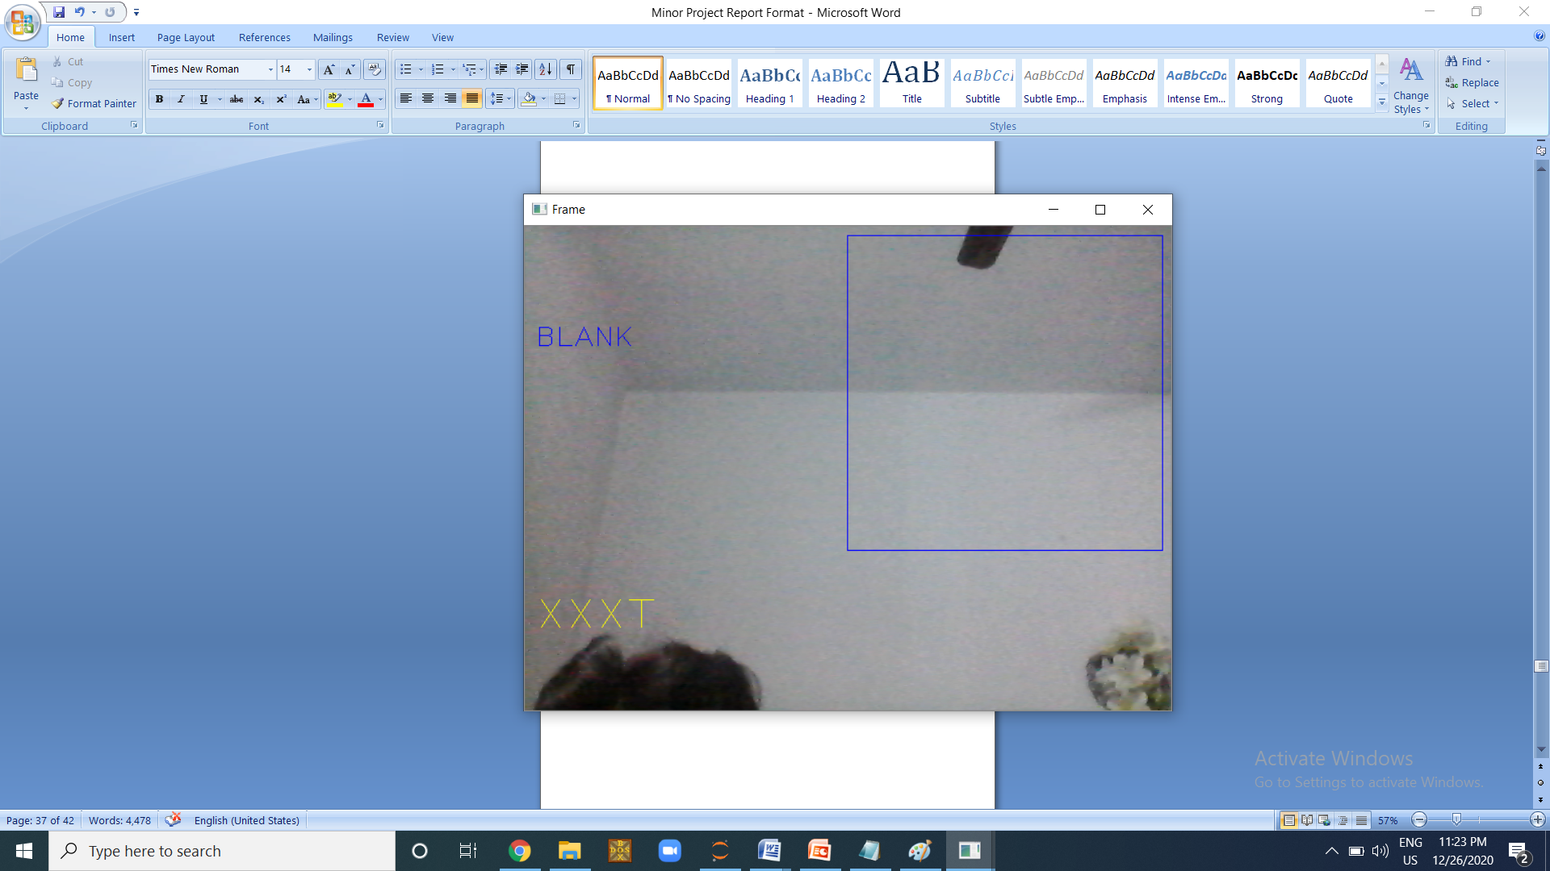

**Character**

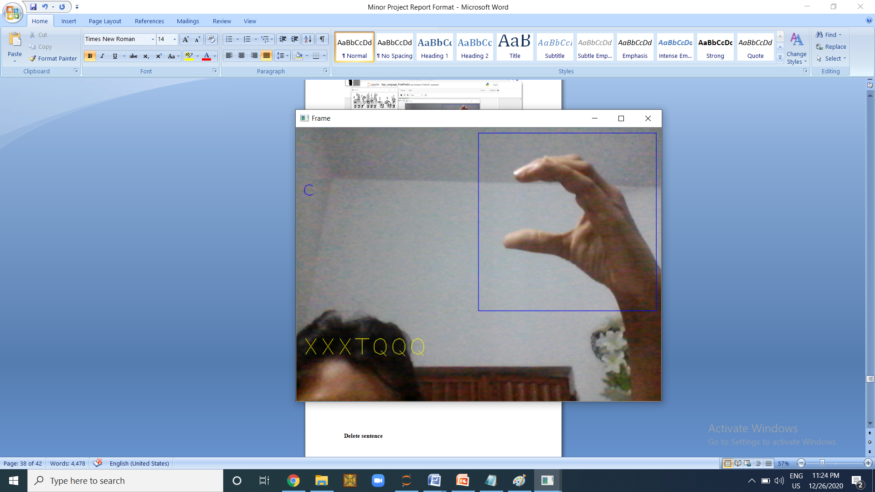

**Space**

